**As a client of ADP TotalSource®, you have a powerful perk available to you!** Advertise your business with ADP Discounts powered by LifeMart and reach nearly a million members.

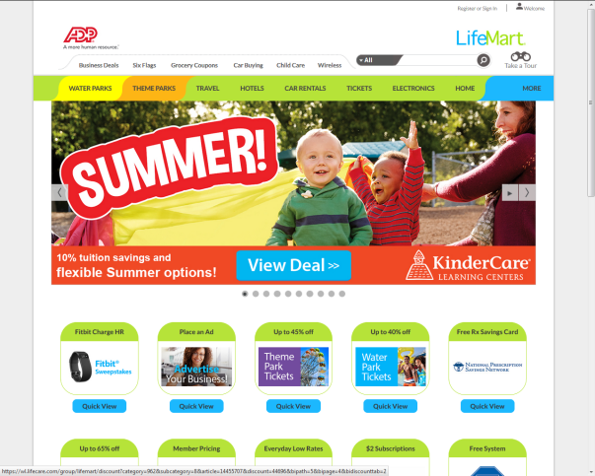

Here’s how to become an advertiser on LifeMart:

1. **Apply directly from the ADP My TotalSource by clicking on this link:** [**http://www.lifecare.com/become-a-lifemart-merchant/**](http://www.lifecare.com/become-a-lifemart-merchant/) **-**OR from the LifeMart homepage click on the *Advertise Your Business* tile.

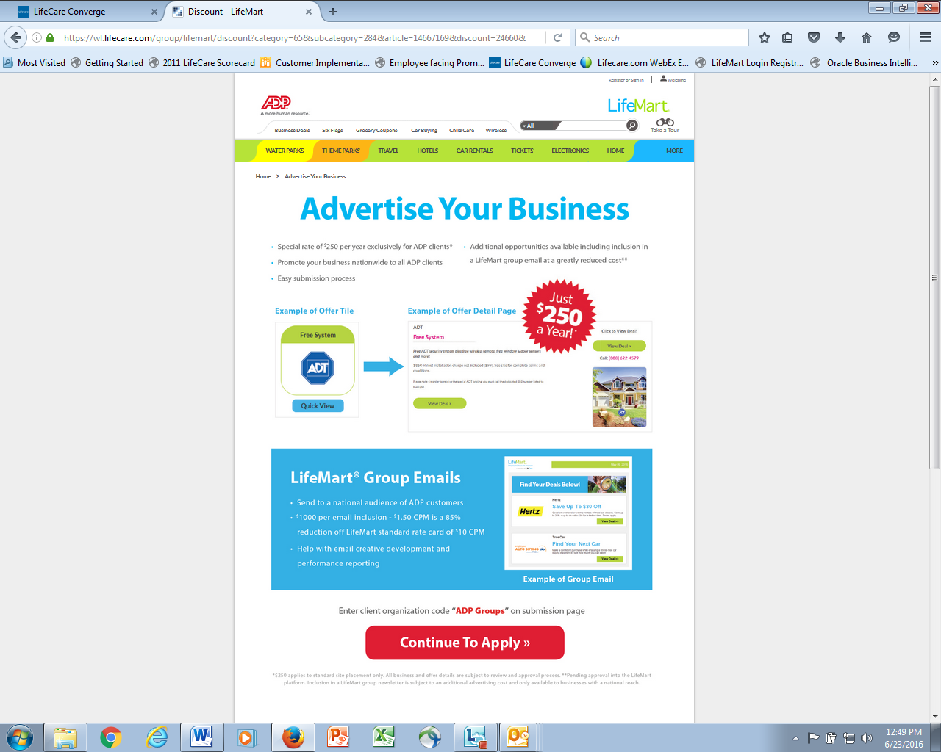

**Click the**

**“Continue to Apply” button to**

**begin the registration.**

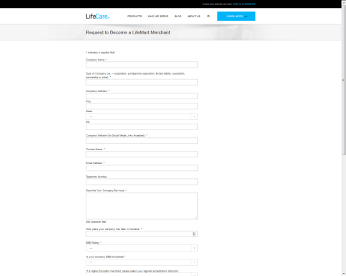

1. **You can complete your submission, indicating the offer you would like to post. You can also click** [**here**](http://www.lifecare.com/become-a-lifemart-merchant/) **to be brought to the page directly.**

* Please enter the code “ADP Groups” in the What LifeCare client organization are you looking to provide your discount to?* box. LifeMart will recognize you as an ADP Advertiser.

1. **Once you click “Send”, the application is sent to the LifeMart team for review.**

* cid:image003.jpg@01D18E5D.36914D90If your ad meets LifeMart merchant criteria – a LifeMart Account representative will contact you to complete the process for ad creation.